|  |  |  |
| --- | --- | --- |
| **شعار جامعة بنها الجديد**f |  |  |
| **Benha University** |  | **Faculty of Computers & Artificial Intelligence** |

**AI-Generated Media Detection System**

A senior project submitted in partial fulfillment of the requirements for the degree of Bachelor of Computers and Artificial Intelligence.

**AI Department.**

**Project Team**

* + - * **Romani Nasrat Shawqi Gerges**
      * **Ahmed Mohamed Ali Abo El-Kassem**
      * **Zeyad Elsayed Abdel-Azim Ali Yousif**
      * **Sara Reda Moatamed Hassan Eissa**
      * **Reham Moustafa Ali Abdel-Moati**
      * **Rawan Abdel-Aziz Ahmed Mahmoud**
      * **Abdallah Mohammed Abdel-monnem**
      * **Mohannad Ayman salah Abdel-fattah**
      * **Mohammed Abdallah Abdel-salam Abdel-Dayem**

**Under Supervision of**

**Dr. Eman Abdel-Latef**

**Eng. Sahar Mohamed**

ABSTRACT

In the dynamic landscape of technological progress, the advent of advanced deep learning techniques, notably Generative Adversarial Networks (GANs)[[1](https://arxiv.org/abs/1406.2661)] and Variational Auto-encoders (VAEs)[[2](https://arxiv.org/abs/1906.02691)], has propelled artificial intelligence (AI) content into a realm of heightened credibility and realism. Among these innovations, the emergence of AI-Generated Media stands out as a powerful tool capable of crafting remarkably authentic synthetic content.

AI-Generated Media, at the crossroads of innovation and deception, opens doors to unprecedented applications in diverse industries like film production, creative arts, and advertising. However, its shadow looms large over Multimedia Information Process and Retrieval (MIPR)[3], challenging facial and speech recognition systems and amplifying the risk of disseminating misleading information.

This project addresses the implications of AI-Generated Media by introducing a comprehensive model designed to discern the origin of multimedia content, be it text or images. Operating as a vigilant guardian, the project employs cutting-edge algorithms to unveil the subtle intricacies of manipulated visuals, safeguarding against deceptive imagery. Furthermore, it encompasses three primary detection models:

1. **AI Image Generation Detection:** A specialized model aimed at identifying images generated by artificial intelligence, distinguishing them from those created by humans.

2. **Text Generation Detection:** Another model tailored to recognize text generated by AI, providing insights into whether the text is authored by human intellect or machine algorithms.

3. **Deepfake Detection:** A robust detection model capable of identifying deepfake content, safeguarding against the manipulation of both images and text.

With a focus on both image and text, the project stands as a resilient shield against the threats posed by AI-Generated Media. Beyond protecting facial and speech recognition systems, its scope extends to safeguarding the societal fabric from the perils of misleading information. By championing transparency, authenticity, and ethical use of AI, this project envisions a future where the authenticity of multimedia content prevails, ensuring a robust and trustworthy digital ecosystem.

Contents

LIST OF ACRONYMS/ABBREVIATIONS 3

Chapter One 4

1. Introduction 4

1.1 Introduction 4

1.2 Problem Definition 4

1.3 Problem Solution 5

1.3.1 Key Features of the Website: 6

1.4 Project Objective 7

1.5 Proposed Scope 8

1.5.1 Key Features: 8

1.5.2 Core Requirements: 8

1.5.3 Scope Exclusions: 8

Chapter Two 9

2 Analysis And Design 9

2.1 Introduction: 9

2.2 User and System Requirements 9

2.2.1 Functional Requirements 9

2.2.2 Non-functional Requirements 10

2.3 Stakeholder List 11

2.4 System Design 12

2.4.1 Use Case Diagram 12

2.4.2 Use case definitions 13

2.5 Activity Diagram 23

2.6 Context diagram 31

2.7 Data flow diagram 32

2.8 Sequence diagram 34

2.9 Class Diagram 36

2.10 Database Design 37

2.11 ERD Diagram 38

2.12 Used Technologies and tools 39

2.13 Summary 40

2.14 Design pattern 40

C h a p t e r Three 42

3 Deliverables and Evaluation 42

3.1 Introduction: 42

3.2 User Manual: 42

3.3 Testing: 42

3.4 Evaluation (User Experiment): 43

3.5 Summary: 43

C h a p t e r Four 44

4 Discussion And Conclusion 44

4.1 Introduction: 44

4.2 Main Findings 44

4.2.1 Why is this project important: 44

4.2.2 Practical Implementations: 45

4.3 Project Constraints 46

4.4 Future Recommendation: 46

4.5 Conclusion Summary: 47

4.6 References: 48

LIST OF ACRONYMS/ABBREVIATIONS

|  |  |
| --- | --- |
| GANs | Generative Adversarial Networks |
| VAEs | Variational Auto-encoders |
| MIPR | Multimedia Information Process and Retrieval |
| LLMs | Large Language Models |

|  |  |
| --- | --- |
|  |  |
|  |  |

# Chapter One

# Introduction

## Introduction

In the ever-evolving realm of artificial intelligence, the race among tech giants to develop groundbreaking technologies like transformers, Generative Adversarial Networks (GANs), and Large Language Models (LLMs)[4] is intensifying. However, with these advancements comes a pressing challenge – the difficulty in discerning AI-generated content from authentic human-created material. This challenge extends to both images and text, raising concerns about the spread of deceptive information and the erosion of trust in online interactions. In response, our project proposes a comprehensive online platform equipped with specialized detector models to address this issue. By leveraging machine learning techniques, we aim to empower users to differentiate between AI-generated and human-created content, thereby promoting transparency and trust in the digital landscape.

## Problem Definition

In the rapidly evolving landscape of artificial intelligence, tech giants like OpenAI, Meta, Microsoft, and Google engage in a competitive race, focusing on groundbreaking technologies such as transformers, Generative Adversarial Networks (GANs), and Large Language Models (LLMs). This fervent competition stems from the realization that AI is a pivotal force shaping the future.

With the emergence of advanced AI, particularly GANs and Transformers, there is a remarkable stride in creating lifelike images. However, this progress brings forth a pressing challenge – the increasing difficulty in distinguishing AI-generated images from real ones. This predicament gives rise to issues like fake profiles, scams, and the dissemination of deceptive information, reminiscent of challenges posed by fake news.

Large Language Models (LLMs) contribute to the predicament by generating text that closely mirrors human language. This poses a unique challenge, especially in educational settings where discerning between authentic student work and AI-generated content becomes intricate.

As open-source technologies advance, the line between machine-generated and human-created text and images blurs, paving the way for malicious actors to produce convincing fake content. Hence, the need for robust systems becomes paramount to discern whether content originates from a machine or a human, preserving trust in online interactions.

## Problem Solution

In response to the challenges posed by advanced AI technologies, particularly in the generation of deceptive content such as deepfakes, our solution is a comprehensive and accessible online platform. We envision constructing a sophisticated website housing specialized detector models designed to address distinct facets of the issue. Our array of detector models includes:

1. **AI-Generated Image Detection Model:**

This model is finely tuned to discern images that have been generated using advanced AI techniques, with a particular focus on identifying content produced by Generative Adversarial Networks (GANs).

1. **Manipulation Detection Model:**

Specifically engineered to identify images whose features have been manipulated by AI, this model aims to expose any alterations or distortions introduced to deceive the viewer.

1. **AI-Generated Text Detection Model:**

In addition to visual content, our platform incorporates a cutting-edge model adept at identifying text generated by AI. This is crucial for distinguishing between human-crafted narratives and those produced by large language models (LLMs).

1. **Web Accessibility for All:**

To ensure widespread utility and user-friendliness, we have chosen to implement these detector models within the framework of an intuitive website. This strategic decision is driven by our commitment to making advanced AI detection technology accessible to users across diverse backgrounds and skill levels.

### Key Features of the Website:

* User-Friendly Interface: The website is designed with simplicity in mind, allowing users to easily navigate and utilize the detection tools without the need for specialized technical knowledge.
* **Multi-Model Integration**: Our platform seamlessly integrates multiple detector models, offering a holistic solution that addresses the nuanced challenges presented by AI-generated images and text.
* **Upload and Analyze Functionality**: Users can effortlessly upload images and text for analysis, receiving detailed insights generated by our detector models.
* **Transparent Reporting**: The analysis results provided by the models are presented in a clear and understandable format, promoting transparency and fostering user trust in the authenticity of the content.
* **Empowering Users Against AI Deception:** By consolidating these detector models into a user-centric website, we aspire to empower individuals, content creators, and organizations with a robust defense mechanism against the threats posed by AI-induced deception. Our solution not only detects and differentiates AI-generated content but also contributes to the broader narrative of fostering transparency and trust in the digital landscape.

## Project Objective

To develop a website utilizing machine learning and data processing techniques to detect images and texts generated by AI, aiming to :

* **Identify AI-Generated Content**: Distinguish images and texts generated by AI models, such as those produced by neural networks.
* **Differentiate Human-Created Content from AI**: Differentiate natural human-generated content from AI-generated content to verify credibility and authenticity.
* **Provide a User-Friendly Interface**: Offer an intuitive user interface for users to upload images and texts for analysis, presenting analysis results in an easily understandable format.
* **Develop Machine Learning Models**: Construct accurate and efficient machine learning models capable of identifying and categorizing suspicious images and texts.

## Proposed Scope

### Key Features:

* **AI-Generated Image Detection**: Identifying images created by AI and distinguishing them from human-created images.
* **AI-Generated Text Detection**: Identifying text generated by AI and discerning it from human-generated text.

### Core Requirements:

* **Machine Learning Model Development**: Building ML models capable of differentiating AI-generated images and texts from human-created ones.
* **Data** **Collection** and Categorization: Gathering a substantial dataset with examples of AI-generated and human-generated images and texts for model training.
* **User** **Interface** Development: Creating a user-friendly interface for users to upload images or texts for analysis.

### Scope Exclusions:

* **Privacy** **and** **Security** **Measures**: Ensuring user data remains secure and doesn’t violate privacy standards.
* **Technical** **Challenges**: Addressing difficulties in detecting advanced, hidden AI techniques.

# Chapter Two

# Analysis And Design

## Introduction:

The analysis and design phase of any software development project is pivotal in shaping the direction and functionality of the final product. In this phase, detailed user and system requirements are identified, serving as the blueprint for the development team. This section delves into the intricacies of the user and system requirements, delineating both functional and non-functional aspects crucial for the development of an AI detection platform. Additionally, stakeholder roles and system design are outlined to provide a holistic understanding of the project scope and objectives.

## User and System Requirements

### Functional Requirements

* **User Authentication:**
  + Users can sign up with a valid email address, name, and password.
  + Users can log in using their credentials.
* **Media Submission:**
  + Users can choose the type of media (text, image, or deep fake).
  + Users can submit the media (upload text or image).
* **Subscription:**
  + Users can subscribe to a plan.
  + Subscription plans are presented to the user.
  + Users can select a plan.
  + Users must pay for the selected plan.
* **Profile Management:**
  + Users, after logging in, can view their profile page.
  + Users can edit their profile information.
* **History:**
  + Users can view a history page that displays their past interactions or submissions.
* **Admin Functions**:
  + Admins can log in.
  + Admins can observe system data and analysis.
  + Admins have access to an admin page.
* **Detection System:**
  + The system can detect AI-generated content.
  + The system records the date and result of the content analysis.

### Non-functional Requirements

* **Security:**
  + User passwords are securely stored (hashed and salted).
  + Media submissions are securely handled to prevent unauthorized access.
* **Usability:**
  + The website has an intuitive and user-friendly interface.
  + Responsive design for various devices and screen sizes.
* **Performance:**
  + The detection system should provide timely results.
  + The website should handle simultaneous user requests efficiently.
* **Scalability:**
  + The system should be able to handle an increasing number of users and media submissions.
* **Reliability:**
  + The system should be available and reliable for users and admins.
* **Payment Processing:**
  + Secure and reliable payment processing for subscription plans.
* **Logging and Auditing:**
  + The system logs user actions, especially those related to media submissions and payments.
  + Admins have access to detailed logs for analysis.
* **Data Backup:**
  + Regular backups of user data and system logs.
* **User Notifications:**
  + Users receive notifications for successful subscription, payment, and other important events.
* **Compliance:**
  + The system complies with relevant data protection and privacy regulations.
* **User Support:**
  + Provide a mechanism for users to seek help or support.
* **Cancellation of Subscription:**
  + Users can cancel their subscription, and the system should handle this process appropriately

## Stakeholder List

* **User:**  Utilizes the website to detect AI-generated images and texts.
* **Admin:** Manages user accounts and profiles.

## [System Design](https://docs.google.com/document/d/1911K8leSaWv2sExP5cNrAUrN4UOGLnyp/edit#heading=h.35nkun2)

### Use Case Diagram

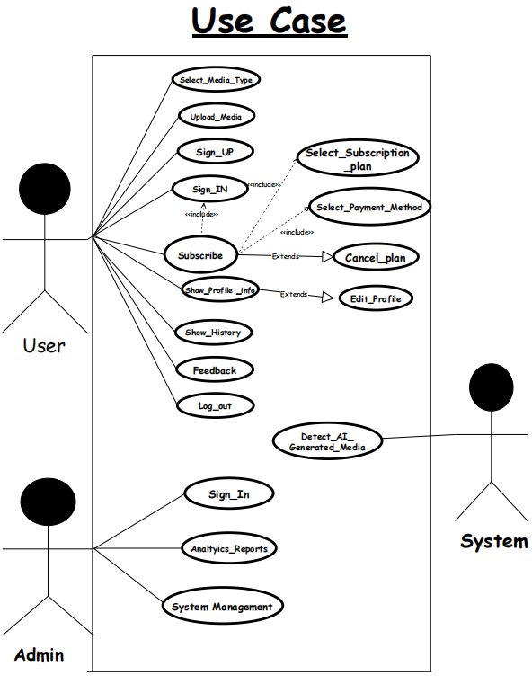

**Figure 1**

### Use case definitions

**-Select Media Type**

|  |  |
| --- | --- |
| **Actor** | **User** |
| **Pre-conditions** | **User is on the main page.** |
| **Post-conditions** | **Media type is selected** |
| **Basic flow** | **1-User navigates to the main page.**  **2-User selects the media type.** |
| **Relationship** | **User - Main Page: The user interacts with the main page to navigate to different sections, including selecting the media type.** |

**-Enter the Media**

|  |  |
| --- | --- |
| **Actor** | **User** |
| **Pre-conditions** | **User has selected a media type.** |
| **Post-conditions** | **Media is entered.** |
| **Basic flow** | **-User selects a media type. -User enters the media.** |
| **Relationship** | **User - Selected Media Type:**  **The user's action of selecting a media type is a prerequisite for entering the media.**  **User - Media Entry:**  **The user interacts with the system to input or provide the media content.** |

**-Sign In or Sign Up**

|  |  |
| --- | --- |
| **Actor** | **User** |
| **Pre-conditions** | **User is on the main page.** |
| **Post-conditions** | **User is signed in or signed up** |
| **Basic flow** | **-User navigates to the main page.  -User chooses to sign in or sign up.** |
| **Relationship** | **User - Main Page:**  **The user's action of navigating to the main page is a prerequisite for signing in or signing up.**  **User - Authentication status:**  **The user interacts with the authentication system during the sign-in or sign-up process** |

**-Select Subscription Plan**

|  |  |
| --- | --- |
| **Actor** | **User** |
| **Pre-conditions** | **User is signed in or signed up.** |
| **Post-conditions** | **User is subscribed to a plan.** |
| **Basic flow** | **-User signs in or signs up.  -The system displays available subscription plans. -User selects a subscription plan based on their preferences. - User makes a payment.** |
| **Relationship** | **User - Authentication Status:**  **The user's sign-in or sign-up status is a prerequisite for subscribing to a plan. User - Subscription Page:**  **The user interacts with the subscription page to choose a plan**  **User - Payment System:**  **The user interacts with the payment system during the subscription process.** |

**-Logout**

|  |  |
| --- | --- |
| **Actor** | **User** |
| **Pre-conditions** | **User is signed in** |
| **Post-conditions** | **User is logged out** |
| **Basic flow** | **-The user, already signed in, clicks on the "Log Out" option.**  **-The system receives the log-out request from the user.**  **-The system updates the user's session status to indicate a logged-out state.**  **-The user is successfully logged out.**  **-The system provides feedback to the user, confirming the successful log-out.** |
| **Relationship** | **User - Authentication Status:**  **The user's sign-in status is a prerequisite for logging out.**  **User - Session Management:**  **The user's session is managed during the logout process.** |

**-Show Profile Info**

|  |  |
| --- | --- |
| **Actor** | **User** |
| **Pre-conditions** | **User is signed in** |
| **Post-conditions** | **The user views their profile information.** |
| **Basic flow** | **-The user, already signed in, navigates to the profile section.**  **-The system displays the user's profile information.** |
| **Relationship** | **User - Profile Component: The user interacts with the profile component during the process, indicating a relationship with the profile feature.** |

**-Show History (Page)**

|  |  |
| --- | --- |
| **Actor** | **User** |
| **Pre-conditions** | **User is signed in.** |
| **Post-conditions** | **User views the history page.** |
| **Basic flow** | **-The user, who is already signed in, navigates to the section or option that allows them to view the history. This could be a button or a link labeled "Show History."**  **-The system recognizes the user's request to view the history and checks for an active session.**  **-If the user has an active session, the system proceeds to the next step.**  **-If the user doesn't have an active session, they may be prompted to sign in again.**  **-The system grants access to the history component since the user has a valid session.**  **-The user interacts with the history component, which could involve navigating through a list of historical data or specifying parameters for the history they want to see.**  **-The system retrieves and displays the relevant history information based on the user's request.**  **-The user views the history page, containing the requested historical data.** |
| **Relationship** | **User - Session:**  **The user needs an active session to access the history page.**  **User - History Component:**  **The user interacts with the history component during the process.** |

**-Edit profile**

|  |  |
| --- | --- |
| **Actor** | **User** |
| **Pre-conditions** | **User is signed in.** |
| **Post-conditions** | **The user successfully updates their profile information.** |
| **Basic flow** | **-The user, already signed in, navigates to the profile section.**  **-The system displays the user's current profile information.**  **-The user selects the option to edit their profile.**  **-The system presents a form with the user's current information for editing.**  **-The user makes desired edits and submits the form.**  **-The system verifies and updates the user's profile information.**  **-If the update is successful, the system notifies the user.**  **-If there are errors, the system displays error messages and prompts the user to correct them** |
| **Relationship** | **User - Profile Component: The user interacts with the profile component to make changes, establishing a relationship with the profile editing functionality** |

**-Select Payment Method**

|  |  |
| --- | --- |
| **Actor** | **User** |
| **Pre-conditions** | **User has selected a subscription plan.** |
| **Post-conditions** | **User has chosen a payment method, and the subscription is activated.** |
| **Basic flow** | **-After selecting a subscription plan, the user proceeds to the payment step.**  **-The system presents various payment methods (credit card, PayPal, etc.).**  **-User selects their preferred payment method.**  **-The system processes the payment and activates the chosen subscription plan.** |
| **Relationship** | **User - Payment Process:**  **The user interacts with the system to choose a payment method and complete the subscription process** |

**-Cancel Plan:**

|  |  |
| --- | --- |
| **Actor** | **-User** |
| **Pre-conditions** | **User has an active subscription.** |
| **Post-conditions** | **User's subscription is canceled.** |
| **Basic flow** | **-User navigates to the subscription management section.**  **-The system displays the user's active subscription details.**  **-User selects the option to cancel the subscription.**  **-The system processes the cancellation request.**  **-The user's subscription is canceled, and they no longer have access to the subscribed features** |
| **Relationship** | **User - Subscription Management:**  **The user interacts with the system to manage their subscription, including canceling the plan.** |

**-Sign In (Admin)**

|  |  |
| --- | --- |
| **Actor** | **Admin** |
| **Pre-conditions** | **The admin is registered in the system with valid credentials.** |
| **Post-conditions** | **-Admin is signed in. -The admin gains access to the admin dashboard.** |
| **Basic flow** | **-The admin navigates to the admin sign-in page.**  **-The system presents a form for the admin to input their credentials (username and password)**  **-The admin enters their valid credentials.**  **-The system verifies the admin's credentials.**  **-If the credentials are valid, the system grants access to the admin dashboard.**  **If the credentials are invalid, an error message is displayed, and the admin is prompted to re-enter their credentials** |
| **Relationships** | **Admin - Authentication status: The admin interacts with the authentication module during sign-in. This relationship signifies the involvement of the authentication system.**  **//Admin - Session: A session is established upon successful sign-in, allowing the admin to interact with the system, indicating a dependency on the session management component.** |

**-Analytics Report**

|  |  |
| --- | --- |
| **Actor** | **Admin** |
| **Pre-conditions** | **Admin is signed in.** |
| **Post-conditions** | **Admin views analysis reports** |
| **Basic flow** | **-The admin, already signed in, navigates to the analytics report section.**  **-The system retrieves and displays analytics reports.** |
| **Relationships** | **Admin - Analytics Report Interaction:**  **The admin interacts with the analytics module to retrieve and view analysis reports, establishing a relationship with the analytics component.**  **Admin - Authorization for Analytics Report:**  **This relationship indicates the need for proper authorization to access and view analytics reports. The authorization component is involved in ensuring the admin has the necessary permissions to access the analytics report feature.** |

**-System Management:**

|  |  |
| --- | --- |
| **Actor** | **Admin** |
| **Pre-conditions** | **Admin is signed in.** |
| **Post-conditions** | **The admin has access to system management tools.** |
| **Basic flow** | **-The admin, already signed in, navigates to the system management section.**  **-The system provides access to various system management tools.** |
| **Relationships** | **-System management tools are available only to authenticated admins.**  **-Actor -Admin: Accesses and utilizes system management tools.** |

**-Detect AI-Generated Media**

|  |  |
| --- | --- |
| **Actor** | Admin |
| **Pre-conditions** | Media is present in the system. |
| **Post-conditions** | **The process concludes with the successful identification of AI-generated media.** |
| **Basic flow** | **-The system initiates the process to analyze media content.**  **-The system utilizes the Media Analysis Module to conduct a thorough analysis of the provided media content.**  **-The analysis involves various checks and assessments to determine the characteristics and patterns within the media.**  **-The system employs the AI Detection component to specifically identify any instances of AI-generated media based on predefined criteria and patterns.**  **-If AI-generated media is detected, the system proceeds to the next step.**  **-If no AI-generated media is detected, the process may end, and the system can provide feedback or log the result.**  **-The system marks or flags the identified media as AI-generated.** |
| **Relationships** | **System - Media Analysis Module**: The system interacts with a media analysis module for the analysis of media content, indicating a relationship with the analysis component.  **System - AI Detection:** There is a relationship with the AI detection component, which is responsible for identifying AI-generated media |

## Activity Diagram

1. Sign up activity.

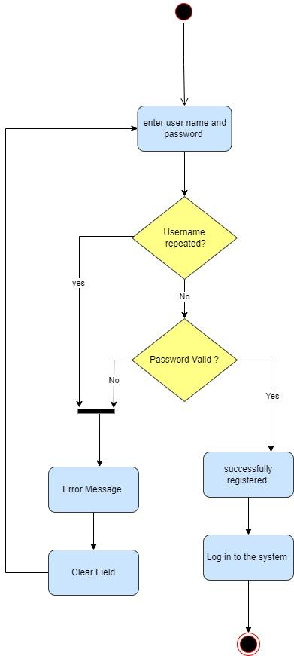

**Figure 2**

1. Sign in activity.

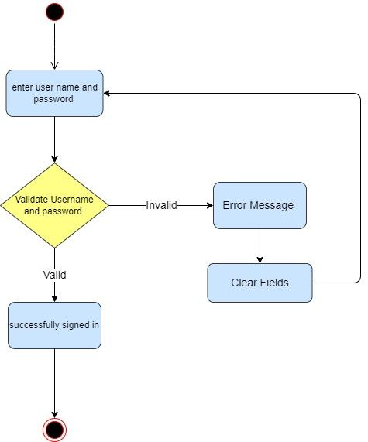

**Figure 3**

1. Select media type activity.

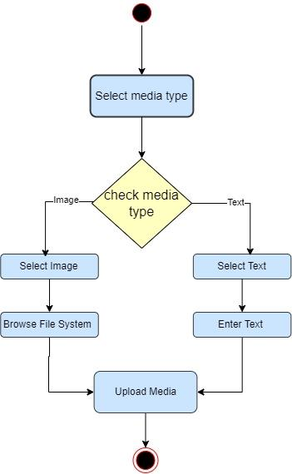

**Figure 4**

1. Upload media activity.

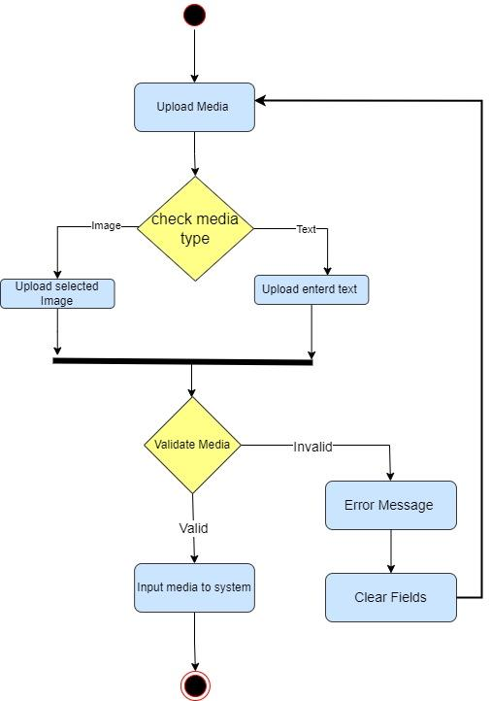

**Figure 5**

Detect Ai-generated Media activity.

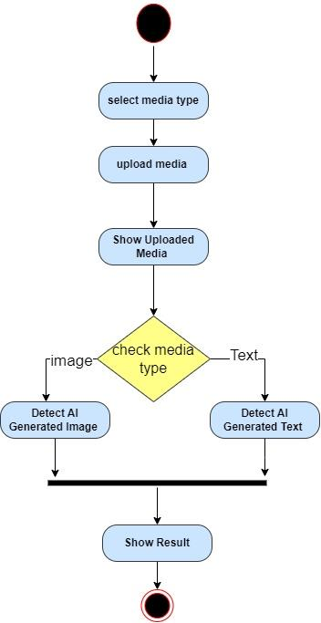

**Figure 6**

1. Feedback activity

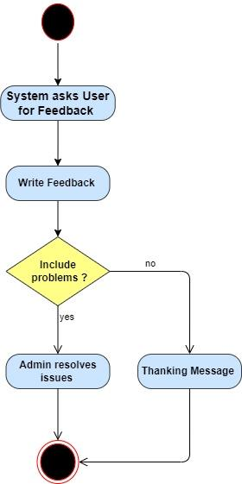

**Figure 7**

1. Subscription activity

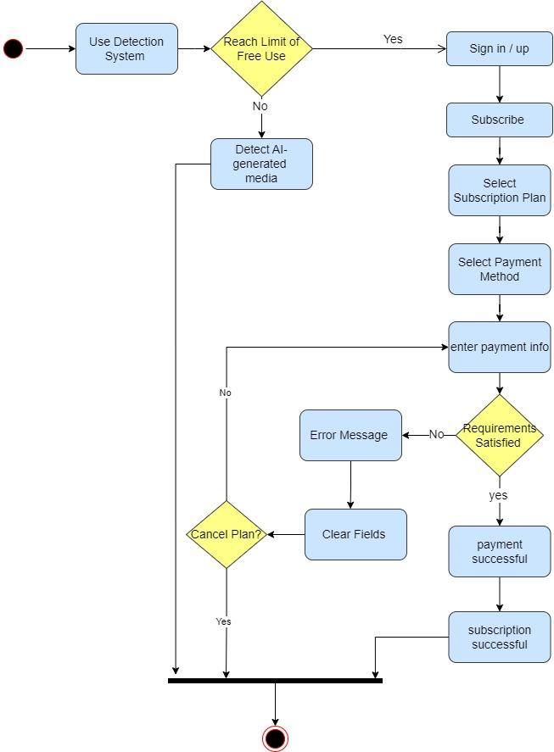

**Figure 8**

1. Admin Management activity.

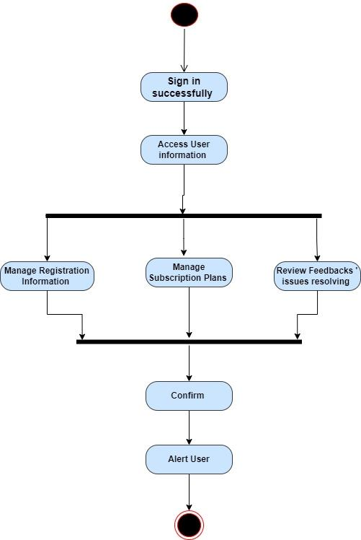

**Figure 9**

1. Show History activity.

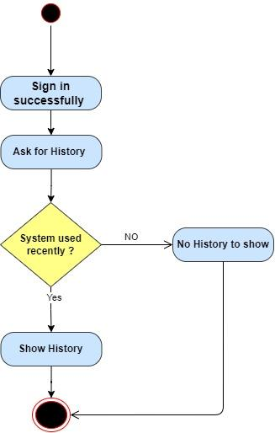

**Figure 10**

1. Edit Profile activity.

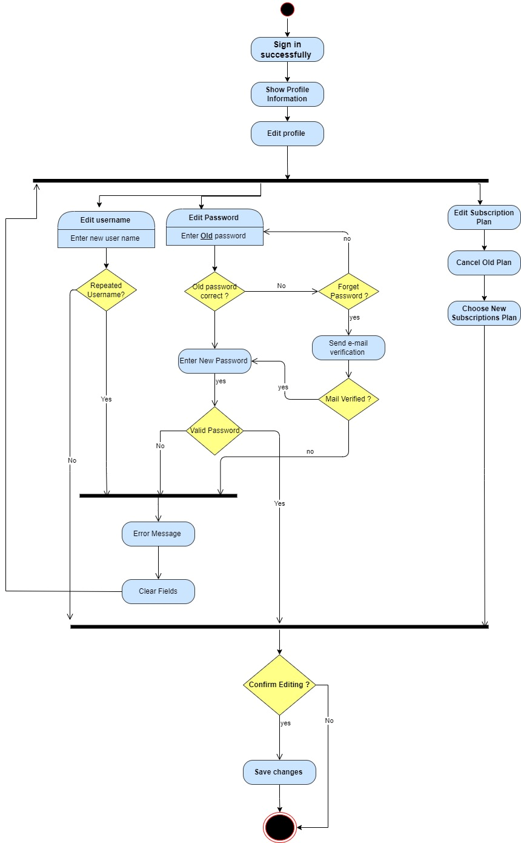

**Figure 11**

## **Context diagram**

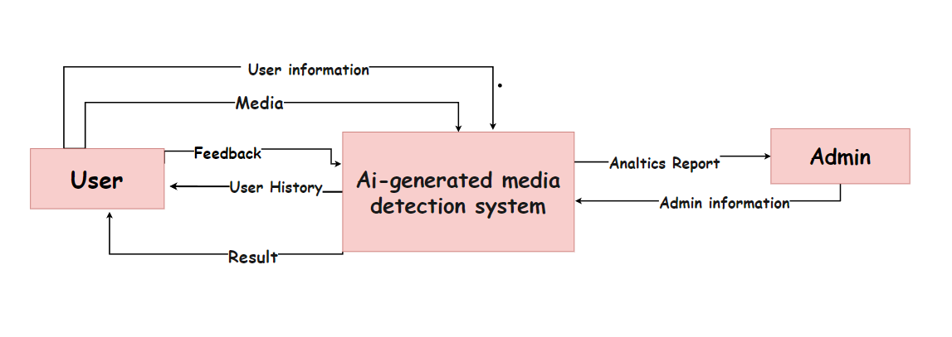

**Figure 12**

## Data flow diagram

1. **Level 0**

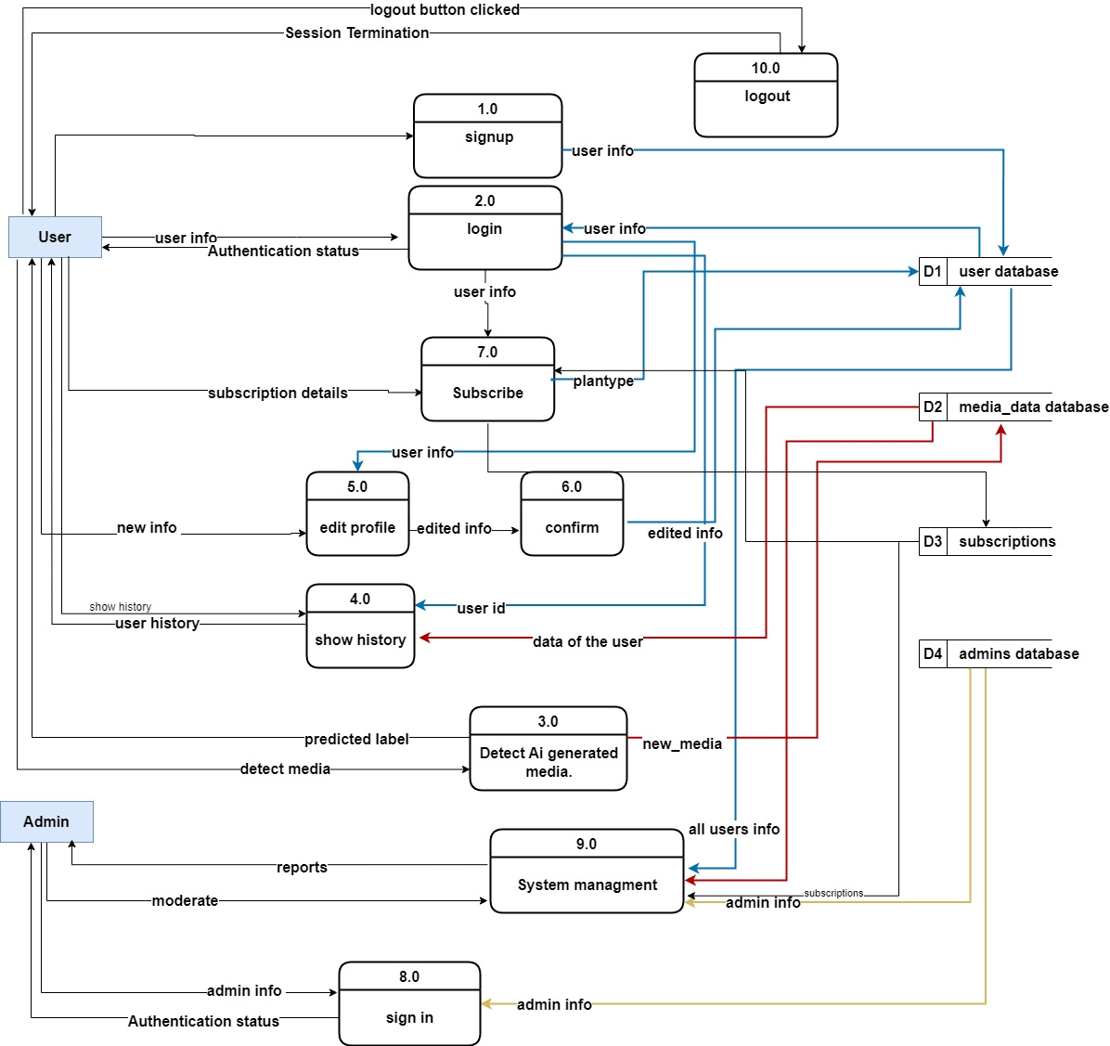

**Figure 13**

1. Level 1

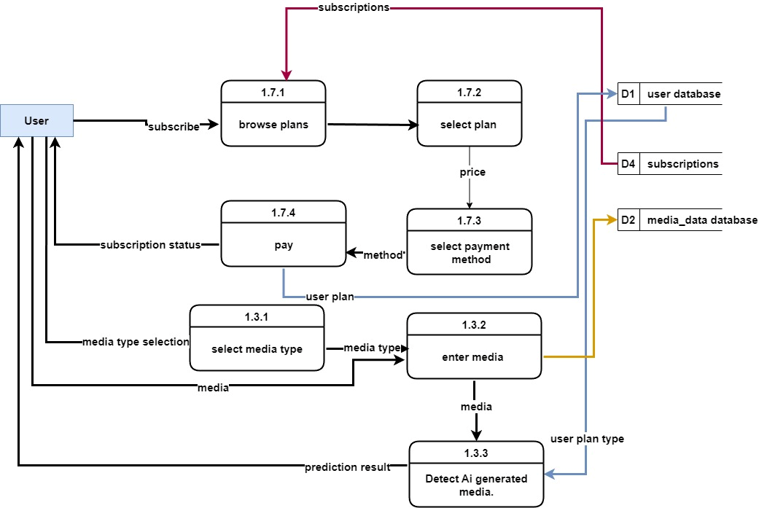

**Figure 14**

## Sequence diagram

1. **User**

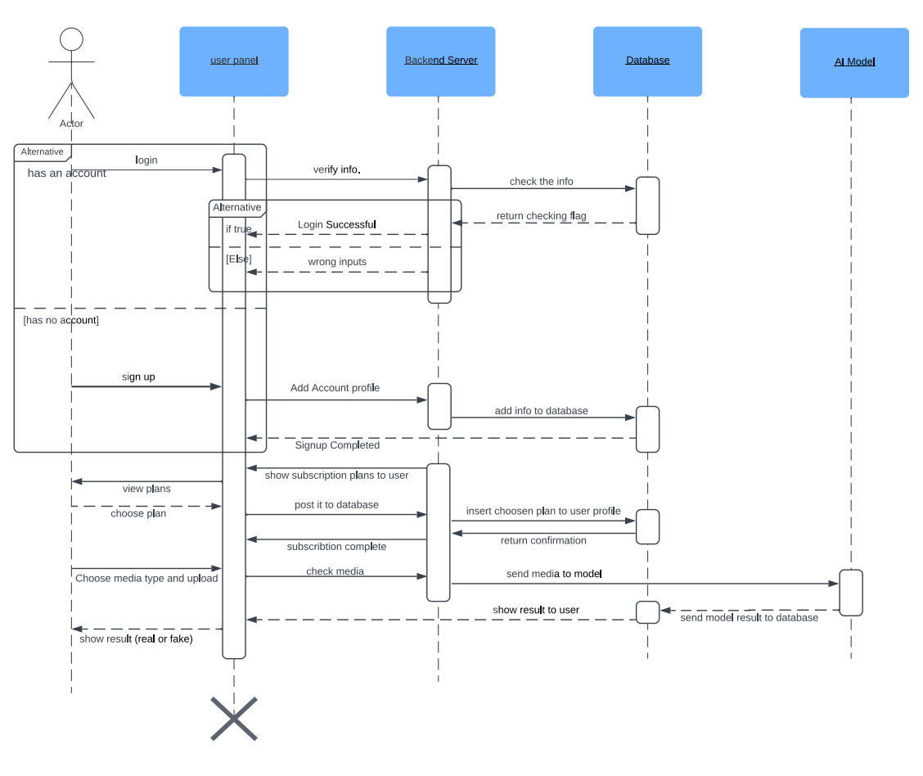

**Figure 15**

1. **Admin**

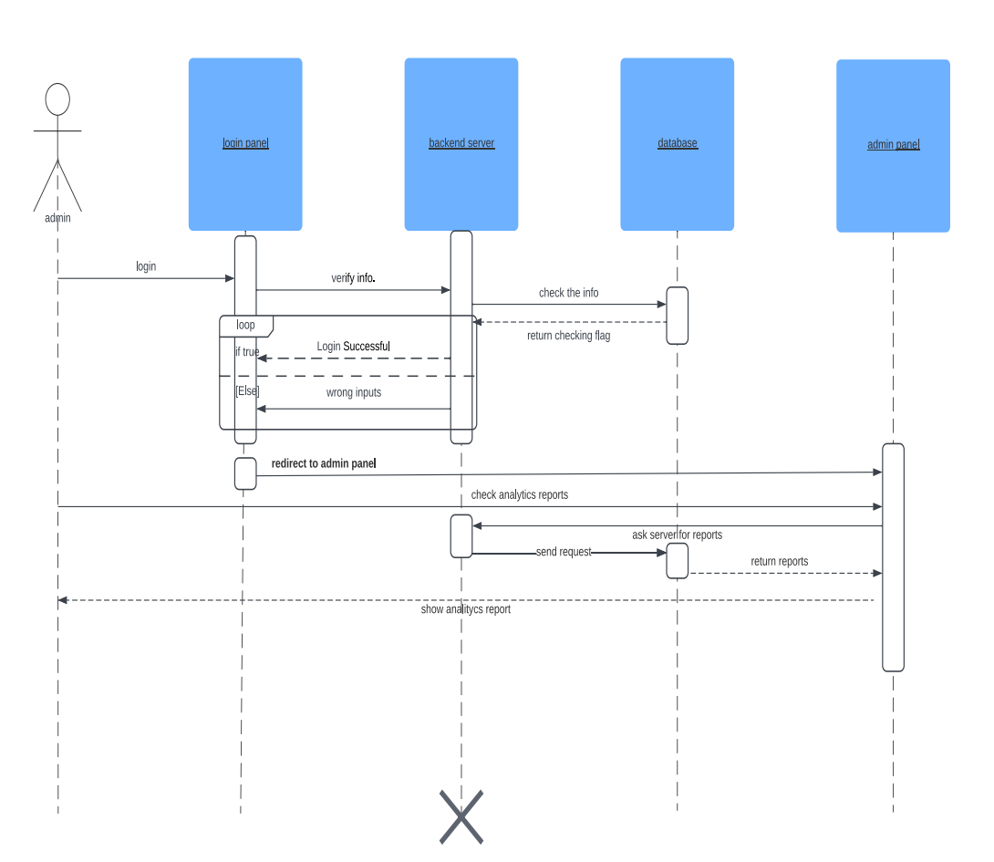

**Figure 16**

## Class Diagram

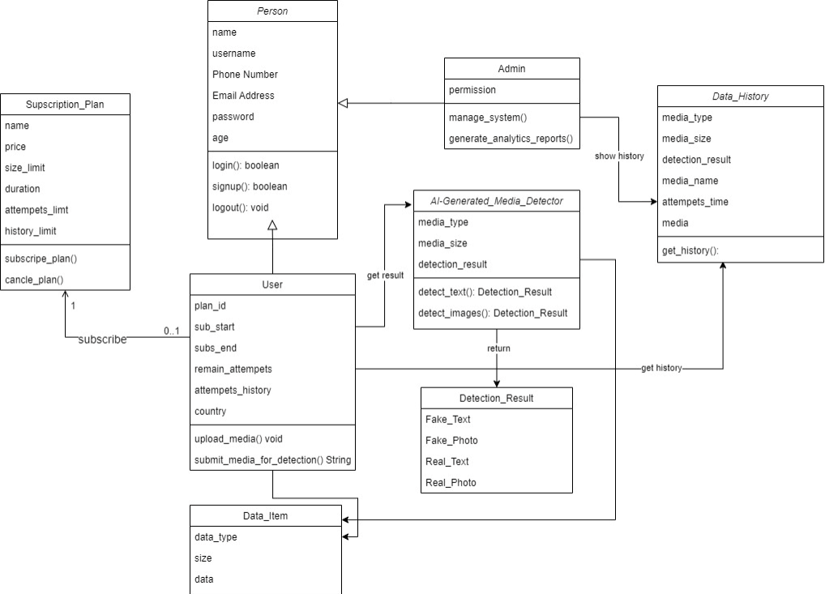

**Figure 17**

## Database Design

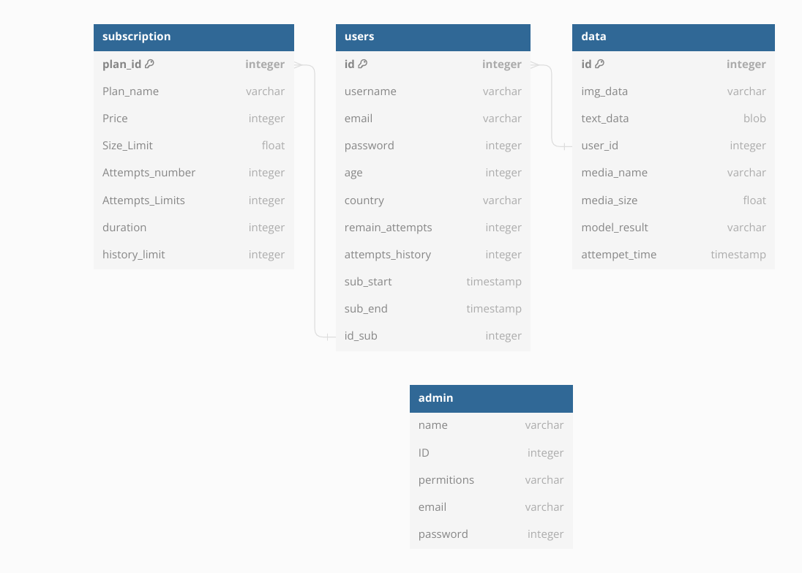

**Figure 18**

## ERD Diagram

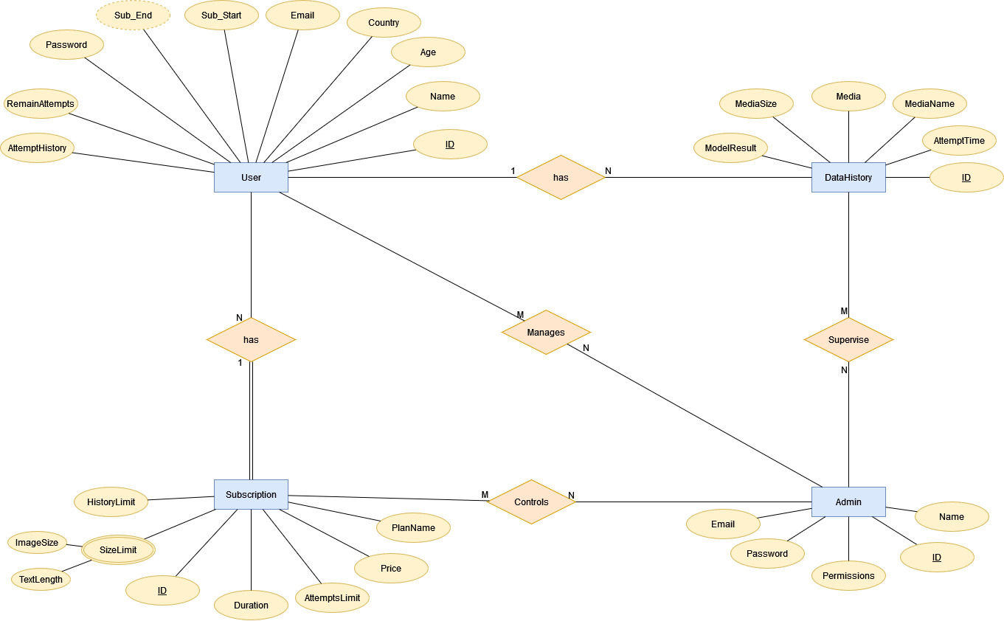

**Figure 19**

## [Used Technologies and tools](https://docs.google.com/document/d/1911K8leSaWv2sExP5cNrAUrN4UOGLnyp/edit#heading=h.4i7ojhp)

* **Frontend Development:**
  + HTML5, CSS3, React, and Bootstrap for building the user interface with responsive design and interactive features.
* **Backend Development:**
  + Django for building the backend server, handling user requests, and managing database interactions.
* **Programming Languages:**
  + Python for machine learning, data processing, and backend development.
  + HTML/CSS/JavaScript for frontend development.
* **Frameworks and Libraries:**
  + TensorFlow or PyTorch for building machine learning models.
  + Django for backend web development.
  + Bootstrap for frontend design.
  + jQuery for frontend interactivity.
  + OpenCV for computer vision tasks.
  + NLP libraries like NLTK, spay, or Transformers for natural language processing.
* **Database**
  + MySQL or PostgreSQL for data storage and management.
* **Development Tools**
  + Git for version control.
  + GitHub or GitLab for collaboration.
  + IDEs like Visual Studio Code or PyCharm for coding.
  + Docker for containerization.
* **Cloud Services:**
  + AWS, Google Cloud Platform, or Microsoft Azure for hosting and deployment.
* **Documentation and Collaboration**
  + Microsoft office word for writing documentation.
* Additionally, **datasets from Kaggle a**nd other sources are used for training and testing machine learning models.

## Summary

The analysis and design phase of the AI detection platform project have been meticulously outlined, focusing on both functional and non-functional requirements essential for its development. Functionalities such as user authentication, media submission, subscription management, and admin functions have been identified to ensure comprehensive coverage of user interactions. Moreover, non-functional aspects including security, usability, performance, scalability, and compliance have been prioritized to guarantee a robust and user-friendly platform. The stakeholder list highlights the key actors involved, while the use case diagram provides a visual representation of the system's functionalities and interactions. Overall, this phase sets the groundwork for subsequent development stages, guiding the implementation process towards the creation of a sophisticated AI detection platform.

## Design pattern

**used design patterns in web development**:

* Model-View-Controller (MVC):
* This pattern separates an application into three main components: Model (data), View (presentation/UI), and Controller (logic).
* Widely used in frameworks like Ruby on Rails, Django, and Laravel.

**Multimodal Architecture:**

* Intent: Integrate multiple modalities (text, image, and deepfake faces) for comprehensive AI-generated media detection.
* Motivation: Enhance accuracy by leveraging diverse data types and patterns associated with AI-generated content.
* Structure: Use a modular architecture where each modality has its processing pipeline and contributes to the final decision.

**Decorator Pattern for Modality Processing:**

* Intent: Dynamically attach additional processing steps to each modality.
* Motivation: Enable flexibility in processing pipelines, allowing easy modification or extension for specific modality requirements.
* Structure: Implement decorators for each modality to add specific processing steps.

**Observer Pattern for Event Handling:**

* Intent: Notify components about detection events or results.
* Motivation: Facilitate real-time updates and coordination between different parts of the system.
* Structure: Establish an observer pattern where components register as observers to receive notifications.

# C h a p t e r Three

# Deliverables and Evaluation

## Introduction:

This chapter presents the key deliverables and evaluation methods for the AI detection platform project. It outlines the various components that will be delivered upon completion of the project, including the user manual, testing procedures, and evaluation criteria. Additionally, this chapter provides an overview of the user experiment planned to assess the effectiveness and usability of the developed platform.

## User Manual:

The user manual is a crucial component of our project, serving as a comprehensive guide for users to navigate the AI detection platform. It will provide step-by-step instructions on utilizing various features such as user authentication, media submission, subscription management, and profile management. Our goal is to ensure that users can effectively utilize the platform to detect AI-generated content and differentiate it from human-created content.

## Testing:

The testing phase involves rigorous evaluation of the platform's functionality, performance, and reliability. Various testing procedures, including unit testing, integration testing, and system testing, will be conducted to identify and rectify any bugs or issues in the software. Additionally, user acceptance testing will be carried out to gauge user satisfaction and validate that the platform meets the specified requirements.

## Evaluation (User Experiment):

To assess the effectiveness and usability of the AI detection platform, a user experiment will be conducted. This experiment will involve a group of participants interacting with the platform and providing feedback on its usability, functionality, and overall experience. The data collected from the user experiment will be analyzed to identify areas for improvement and refinement of the platform.

## Summary:

Chapter 3 concludes with a summary of the deliverables and evaluation methods outlined in the chapter. It highlights the importance of providing a user manual to guide users in using the platform effectively. Additionally, it emphasizes the significance of thorough testing and evaluation to ensure the platform's quality and usability. Overall, this chapter sets the stage for the successful completion and evaluation of the AI detection platform project.

# C h a p t e r Four

# Discussion And Conclusion

## Introduction:

In this chapter, we delve into the development journey of our AI detection platform, which aims to differentiate between media generated by AI and that created by humans. We explore the significance of this project, discuss our main discoveries, outline practical ways to use the platform, address the limitations we encountered, and provide suggestions for future improvements.

## Main Findings

Throughout the project, we discovered that the advancement of AI technologies, particularly Generative Adversarial Networks (GANs) and Large Language Models (LLMs), has ushered in a new era of AI-generated media characterized by heightened realism and credibility. Our comprehensive model comprising specialized detection algorithms successfully identified AI-generated content across both images and text, providing a vital defense against deceptive media practices.

### Why is this project important:

**1. Tackling AI-Made Content Surge:**

- The project deals with the increasing use of AI-generated media.

- It fights against fake content that can harm different industries and society.

**2. Promoting Honesty and Realness:**

- By helping to tell apart AI-made and human-made content, the platform supports honesty.

- It stresses the need for genuine online interactions, especially when false information is common.

**3. Upholding AI Ethics:**

- The project highlights the moral side of AI technology.

- It pushes for AI to be used responsibly and ethically, following society's rules.

**4. Building Digital Trust:**

- By distinguishing between AI and human content, the platform builds trust online.

- It reduces the chances of false information spreading, making online content more believable.

**5. Reducing Fake Content Risks:**

- By letting users spot AI-generated content, the project lowers the risk of spreading false information.

- It gives users a way to check if online content is genuine, making it harder for misinformation to spread.

### Practical Implementations:

The practical implementations of our AI detection platform extend beyond mere detection capabilities. By integrating user-friendly interfaces, multi-model integration, transparent reporting mechanisms, and web accessibility features, we empower users to actively combat AI-induced deception in their digital experiences. Our platform serves as a resilient shield, protecting facial and speech recognition systems while contributing to the broader narrative of fostering transparency in the digital landscape.

## Project Constraints

* **Time Limitations**: Fixed deadlines or timeframes for project completion that might affect the depth of development or testing phases.
* **Resource Constraints**: Limited budget for acquiring necessary tools or technologies, or constraints on available workforce.
* **Technological Limitations**: Mandated use of specific programming languages, frameworks, or restrictions on employing certain AI models due to compatibility issues.
* **Regulatory Compliance**: Adherence to data protection laws, privacy regulations, or ethical guidelines governing the use of AI-generated content.
* **Scope Creep Management**: Ensuring the project remains focused on its defined objectives without expanding beyond the established scope.

## Future Recommendation:

**1. Enhanced Model Accuracy:**

- Invest in research and development efforts to improve the accuracy of detection models, ensuring better performance in identifying AI-generated media with higher precision and recall rates.

**2. Dataset Expansion and Diversity:**

- Expand the dataset used for training detection models to include a more diverse range of AI-generated media examples, covering various genres, styles, and manipulation techniques to enhance model generalization and robustness.

**3. Adapting to Emerging AI Techniques:**

- Stay abreast of advancements in AI generation techniques and adapt detection algorithms accordingly to effectively identify and mitigate risks posed by evolving forms of AI-generated media.

**4. User Privacy and Security Measures:**

- Strengthen user privacy and security measures within the platform to safeguard sensitive information and ensure compliance with data protection regulations, thereby enhancing user trust and confidence.

**5. Collaboration with Regulatory Bodies:**

- Collaborate with regulatory bodies and industry stakeholders to establish guidelines and standards for the responsible use of AI-generated media, fostering ethical practices and mitigating potential risks associated with deceptive content.

**6. Continuous User Education:**

- Develop educational resources and awareness campaigns aimed at educating users about the implications of AI-generated media, empowering them to critically evaluate digital content and make informed decisions online.

**7. Real-Time Detection Capabilities:**

- Implement real-time detection capabilities within the platform to enable instantaneous verification of multimedia content, providing users with timely insights into the authenticity of digital media.

**8. Cross-Platform Integration:**

- Ensure seamless integration and compatibility of the detection platform across various devices and operating systems, enabling users to access and utilize detection tools conveniently across different platforms.

## Conclusion Summary:

In summary, our AI detection platform is a significant advancement in countering the challenges brought by AI-generated media. By harnessing state-of-the-art algorithms and prioritizing user-friendly design, we've developed a robust solution against deceptive content. As we navigate the ever-changing AI landscape, our steadfast commitment to transparency, authenticity, and ethical AI usage ensures a more reliable digital environment for all.

## References:

1. <https://arxiv.org/abs/1406.2661>
2. <https://arxiv.org/abs/1906.02691>
3. <https://ieeexplore.ieee.org/document/8396975>
4. <https://arxiv.org/abs/2005.14165>